# CS 255 Business Requirements Document

Complete this template by replacing the bracketed text with the relevant information.

This template lays out all the different sections that you need to complete for Project One. Each section has guiding questions to prompt your thinking. These questions are meant to guide your initial responses to each area. You are encouraged to go beyond these questions using what you have learned in your readings. You will need to continually reference the interview transcript as you work to make sure that you are addressing your client’s needs. There is no required length for the final document. Instead, the goal is to complete each section based on your client’s needs.

**Tip:** You should respond in a bulleted list for each section. This will make your thoughts easier to reference when you move into the design phase for Project Two. One starter bullet has been provided for you in each section, but you will need to add more.

## System Components and Design

### Purpose

*What is the purpose of this project? Who is the client and what do they want their system to be able to do?*

* The client, DrivePass, wants to help customers of their local Department of Motor Vehicles to pass their driving tests. DrivePass wants to build a better training program and help developing a system which gives customers the chance to take online classes, practice tests, and on-the-road training.

### System Background

*What does DriverPass want the system to do? What is the problem they want to fix? What are the different components needed for this system?*

* DrivePass wants to solve the problem of driving students no passing their driving tests at their local DMV. The system DrivePass wants is to be used by the owner, IT officer, the secretary, and the customers.
* The system components needed are: several webpages, available access for the owner to download information, access for tracking activity, access from PC and Mobile devices, use of cloud storage, connection to the DMV system, schedule for cars and trainer drivers, access to be able to disable and modify a package, and a specific look provided by DrivePass.

### Objectives and Goals

*What should this system be able to do when it is completed? What measurable tasks need to be included in the system design to achieve this?*

* Once completed the system will allow customers to create an account online which includes adding their information of: first name, last name, phone number, address, state, and credit card information. The secretary can also use the system to add customer information that the customer provides over the phone.
* After an account creation the customers can purchase a package that DrivePass offers
* The customer can schedule their two hour block of on-the-road training, schedule in-person lessons, take online courses, take practice tests, and modify or cancel reservations.
* The customer’s home page will have the following: a logo at the top center, their information in a space under the logo to the right, a space under the logo to the left that features the customer’s online test progress statuses, under that is a space for driver trainer notes in a table format, under customer information is space for any special needs, and under that is a space for both the driver trainer’s photo and the customer’s photo.
* The owner will have full access which they will be able to download information to their device, be able to track activity made on the web pages, able to modify or disable packages, reset employee passwords, and block former employee’s access
* The system is connected to the DMV system for updates on policies and will show DVM policies and information

## Requirements

### Nonfunctional Requirements

*In this section, you will detail the different nonfunctional requirements for the DriverPass system. You will need to think about the different things that the system needs to function properly.*

#### Performance Requirements

*What environments (web-based, application, etc.) does this system need to run in? How fast should the system run? How often should the system be updated?*

* The system will run on both web-based and mobile environments.

Google Chrome™, most recent stable version and two preceding versions.

Mozilla® Firefox®, most recent stable version and two preceding versions.

Apple® Safari® for MacOS and iOS, two most recent major versions.

Microsoft® Edge®1 most recent stable version and two preceding versions

* Access to the DMV system for updates from DMV when policies or rules change

Rationale: Having the system be able to run on two previous versions of the environments lets more users use the system. Updating periodically will allow the system to update and new policies or rules, and keep the system from crashing.

#### Platform Constraints

*What platforms (Windows, Unix, etc.) should the system run on? Does the back end require any tools, such as a database, to support this application?*

* The system will run on Windows, Android, MacOS, and IOS
* The back-end will have a database
* Cloud based

Rationale: The system will support the local area to people needing to get a driver’s license so there is will not be a large amount of traffic using the site but will need to accommodate multiple users. The back-end database will need to store information pertaining to the tests, courses, and user information.

#### Accuracy and Precision

*How will you distinguish between different users?* *Is the input case-sensitive? When should the system inform the admin of a problem?*

* The use of session cookies
* Passwords are case sensitive
* Administration notification immediately for critical errors, store all errors in a report

Rationale: The front-end of the web page will use session cookies to distinguish the different users (Ramzy 2023). Having each password be different with case sensitivity will lower the chance of an accidental account access or hacking into an account by unauthorized persons. Immediate notification to administration of errors that are critical will allow the department to act upon and fix the errors. Having the errors in a report will allow administration to see where minor errors occurred and if they are reoccurring.

#### Adaptability

*Can you make changes to the user (add/remove/modify) without changing code? How will the system adapt to platform updates? What type of access does the IT admin need?*

* Changes to users will be done with out changing the code.
* Database access needs to be provided to the IT administration team.

Rationale: Changes can be done on the back-end without changing the source code. The IT administration team needs access the database for modifications to information.

#### Security

*What is required for the user to log in? How can you secure the connection or the data exchange between the client and the server? What should happen to the account if there is a “brute force” hacking attempt? What happens if the user forgets their password?*

* A secure connection is made with HTTPS protocol encryption
* Authentication shall be implemented for each user with login credential consisting of a password and user name, which are case sensitive.
* Users are able to retrieve their password, when forgotten, via a “forgot password” link
* The system will lock out an account when a set amount of failed login attempts is made, the set amount is 3.

Rationale: Using the HTTP protocol to encrypt information, the website can be trusted for users to enter their personal information (Cloudflare 2024). The website will use authentication process to have all users with different usernames and protected by a password. The user can retrieve their password if forgotten or change it but the system will lock an account after three unsuccessfully attempts to access the account.

### Functional Requirements

*Using the information from the scenario, think about the different functions the system needs to provide. Each of your bullets should start with “The system shall . . .” For example, one functional requirement might be, “The system shall validate user credentials when logging in.”*

* The system shall enable the owner to disable provided packages.
* The system shall allow the owner to track usage, generate reports, and download reports
* The system shall allow the secretary to create, modify, and delete users
* The system shall allow users to create and modify their accounts
* The system shall allow access to the website via a mobile friendly browser based interface or mobile application
* The system shall allow the user to schedule in-person drive times, take online tests, schedule in-person lessons, and online courses
* The system shall allow users to see their dashboard of test and course statuses.

Rationale: The system will allow the users of owner, secretary, and customer to access the website via mobile friendly browsers. Allowing the owner to access reports of usage allows them to take care of any discrepancies or find where a problem started and by whom. The owner is allowed to disable packages accordingly for business and staffing purposes. The system will allow the modification to users’ information from users or the secretary when needed, as well as the secretary deleting users who are no longer using the system. Users are allowed to use the system for all scheduling purposes, test taking, and viewing the status of their tests via a dashboard.

### User Interface

*What are the needs of the interface? Who are the different users for this interface? What will each user need to be able to do through the interface? How will the user interact with the interface (mobile, browser, etc.)?*

* Browser users will need a computer with keyboard and mouse, accessibility features such as on-screen keyboard will work as well
* Mobile users will need the phone or tablet device with touch screen, optional keyboard attachment for typing will work as well
* User interface will consist of selecting link buttons on the website and typing in information where needed

Rationale: The user will interact with the website on a computer with supported hardware and software. They will first navigating to the website via URL, enter login information with clicking with the mouse and typing with the keyboard, then selecting by clicking their next step on the website. Next steps include scheduling, test status, driver information, user information, and online courses.

### Assumptions

*What things were not specifically addressed in your design above? What assumptions are you making in your design about the users or the technology they have?*

* The customer will have access to the appropriate technological requirements to run the system.
* All customers are knowledgeable enough to use the system
* All customers will have access to the internet.

Rationale: Listed are the assumptions that there is adequate access to internet for all customers and they also have access to the required hardware and software to run the system. There is also the assumption that all users have the technological knowledge to use the system.

### Limitations

*Any system you build will naturally have limitations. What limitations do you see in your system design? What limitations do you have as far as resources, time, budget, or technology?*

* Limited user access when system updating
* Owner not sure on how future features

Rationale: With a lack of thinking of future features, the system could stagnate. The access to the system will be limited when there is an update.

### Gantt Chart

*Please include a screenshot of the GANTT chart that you created with Lucidchart. Be sure to check that it meets the plan described by the characters in the interview.*

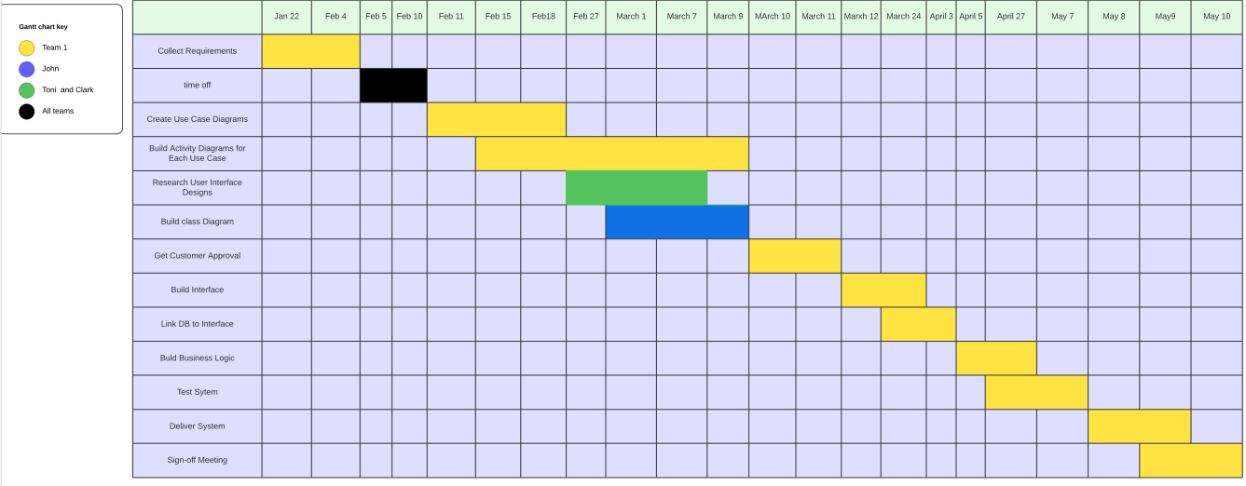

Resources

Cloudflare.(2024). https://www.cloudflare.com/learning/ssl/why-use-https/

Ramzy, Hendel.(March4, 2023).Medium. How session and cookies works?. https://medium.com/@hendelRamzy/how-session-and-cookies-works-640fb3f349d1